`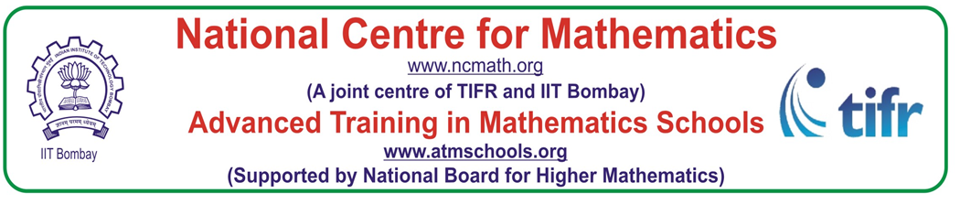

IST-Multivariable Calculus and Differential Forms (2022)

Venue: Bhaskaracharya Pratishthana, Pune

(5th December 2022 – 17th December 2022)

Starting from the review of some important results in Multivariable Calculus and Linear Algebra, the workshop offers an introduction to the notion of a manifold and differential forms. The later part of the workshop is devoted to the integration of a differential form over a manifold and Stokes’ theorem. The workshop is intended for teachers and research students.

General Information

Last Date for receiving online applications: 28th November 2022

Number of Participants: 40 participants (15 outstation and 25 Local participants)

The email Id for any correspondence regarding this IST is [bhaskaraprim@gmail.com](mailto:bhaskaraprim@gmail.com)

The list of selected applicants will be put up on the website after two days of last date of submission.

Webpage of the Programme:

<https://www.atmschools.org/school/2022/IST/mcdf>

Application form is available on the above website

Orthogonal Transformations, Orthogonal Matrices, Volume of parallelopiped

Dr. Rakesh Pawar,

Post Doctoral fellow, IISER, Pune

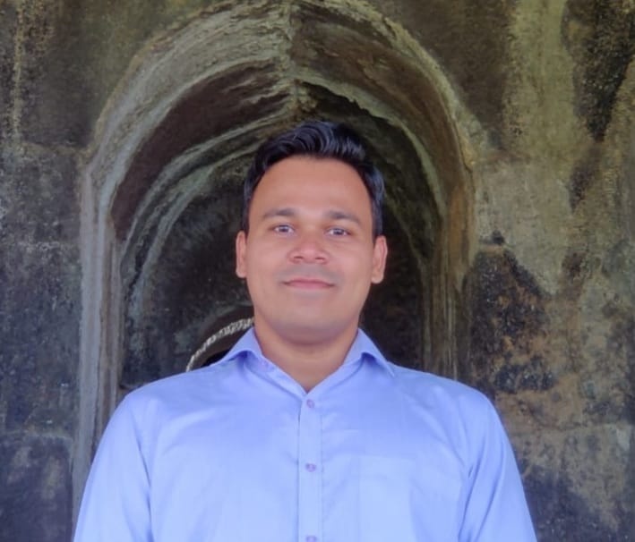

Integrating forms over manifolds, Stokes’ Theorem

Prof. Gopal Krishna Srinivasan,

Professor, IIT, Bombay

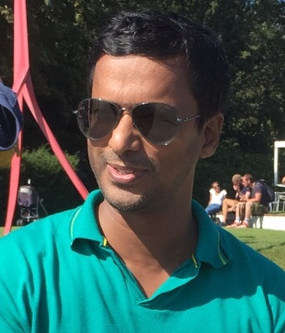

Implicit and Inverse function Theorems

Dr. Saurabh Shrivastava,

Head and Associate Professor,

IISER, Bhopal

Multilinear Algebra, Alternating tensors, Wedge Product, Differential Forms,

The differential Operator

Prof. Vinayak Sholapurkar

Professor, S. P. College, Pune



Differentiability of multivariable functions, Manifolds, Boundary of Manifold, orientation of manifold

Dr. V. V. Acharya,

Associate Professor, Fergusson College, Pune

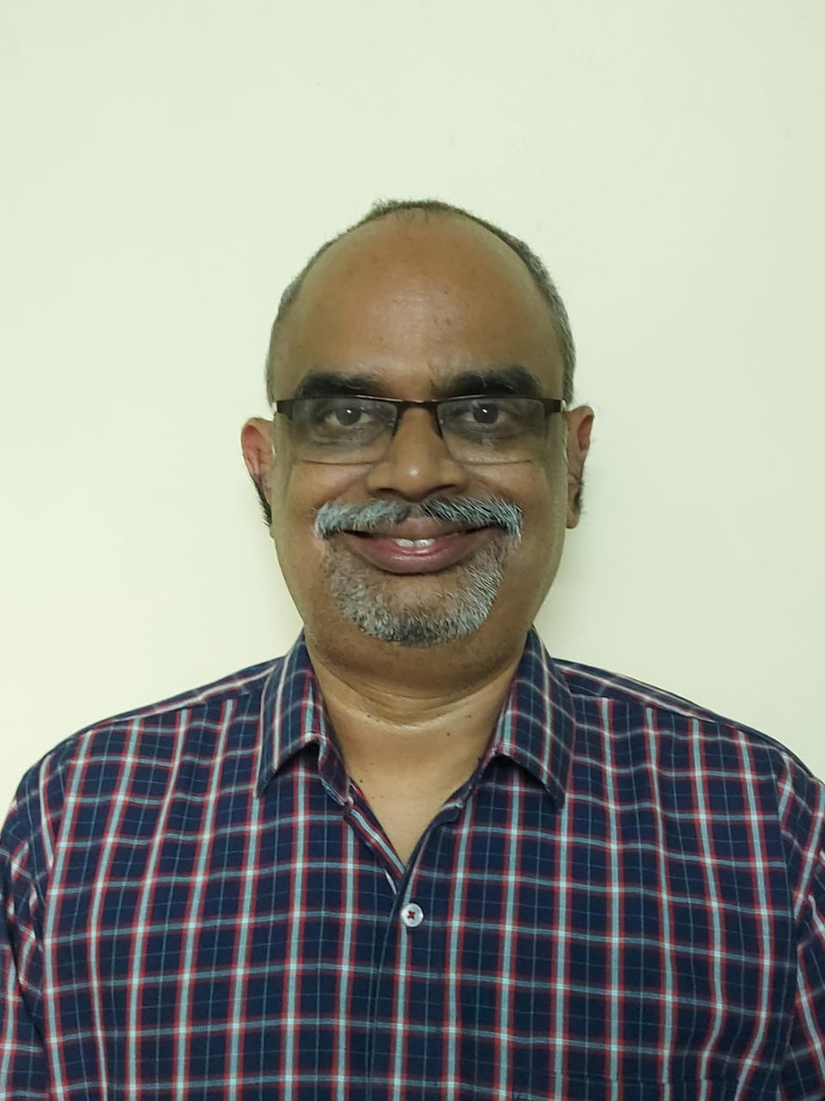

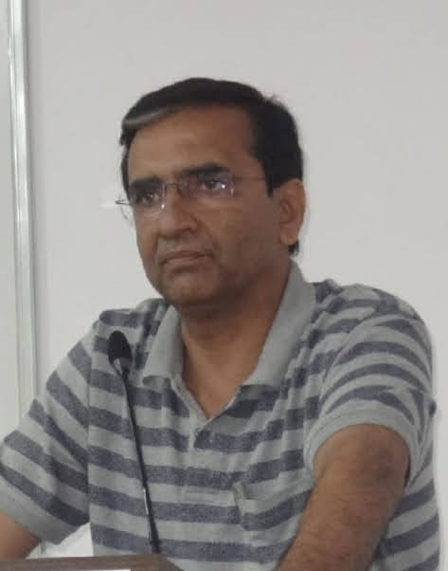

Organizers

Speakers

Dr. Geetanjali M. Phatak,

Assistant Professor, S. P. College, Pune gmphatak19@gmail.com

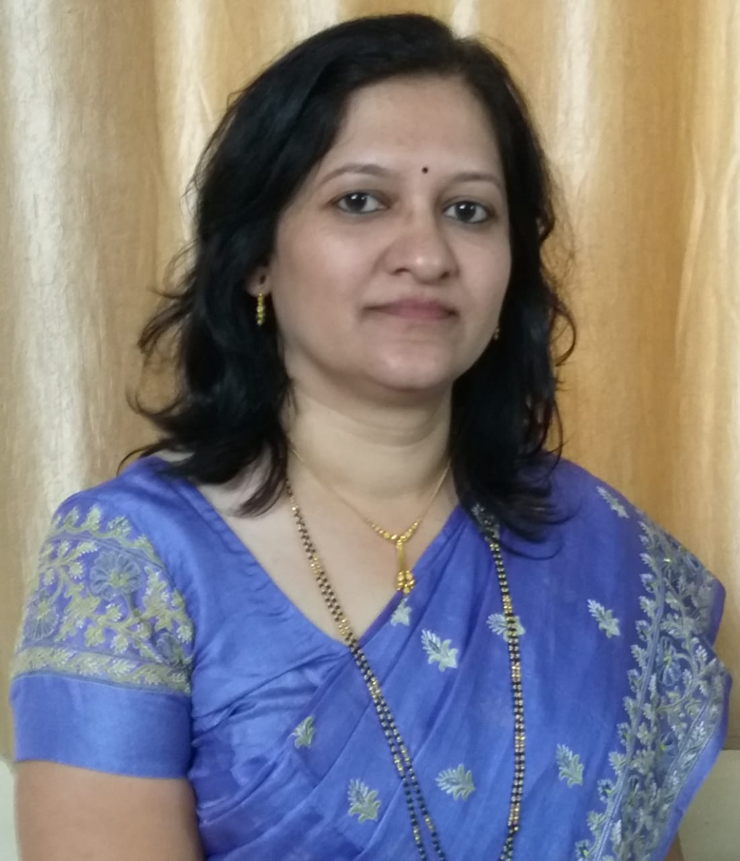

Dr. V. V. Acharya,

Associate Professor,

Fergusson College, Pune vvacharya@gmail.com

